# Name- Mayuri siddhu Bandgar Batch code-7669

**HTML- Hypertext Markeup Language.**

With HTML you can create your own Website.

# Project name- Mobile Store

Mobile Phone is an electronic device used for communication and messaging. Now days this has become very popular and essential need of the society. These are available in various make and brands in the market. Therefore repairing and servicing of mobile phones are also required to be done. This has got a prospective market.

**Purpose-** Mobile Shop means a registered means of transportation installed as a point of sale of food and/or non-food products where residents of townships and villages are served in accordance with the procedure laid down by the municipal council.

**Language used-** HTML, CSS, JavaScript

HTML-

* HTML is Standard markup language.
* HTML is the standard markup language for creating Web pages.
* HTML describes the structure of a Web page.
* The <!DOCTYPE html> declaration defines that this document is an HTML5 document
* The <html> element is the root element of an HTML page
* The <head> element contains meta information about the HTML page
* The <title> element specifies a title for the HTML page (which is shown in the browser's title bar or in the page's tab)
* The <body> element defines the document's body, and is a container for all the visible contents, such as headings, paragraphs, images, hyperlinks, tables, lists, etc.
* The <h1> element defines a large heading
* The <p> element defines a paragraph

## The <!DOCTYPE> Declaration

## The <!DOCTYPE> declaration represents the document type, and helps browsers to display web pages correctly.

## It must only appear once, at the top of the page (before any HTML tags).

The <!DOCTYPE> declaration is not case sensitive.

The <!DOCTYPE> declaration for HTML5 is: <!DOCTYPE html>

## HTML Headings

HTML headings are defined with the <h1> to <h6> tags.

<h1> defines the most important heading. <h6> defines the least important heading:

<h1>This is heading 1</h1>  
<h2>This is heading 2</h2>  
<h3>This is heading 3</h3>

## HTML Paragraphs

HTML paragraphs are defined with the <p> tag:

<p>This is a paragraph.</p>  
<p>This is another paragraph.</p>

## HTML Links

HTML links are defined with the <a> tag:

<a href="https://Amazon.com">This is a link</a>

## HTML Images

## HTML images are defined with the <img> tag.

The source file (src), alternative text (alt), width, and height are provided as attributes:

<img src="C:\Users\Mayuri\Desktop\mobile img\mobile1.jpg"  width="350" height="350">

## HTML Elements

The HTML **element** is everything from the start tag to the end tag:

<tagname>Content goes here...</tagname>

<h1>MOBILE STORE</h1>

<p>Welcome to Guys</p>

## HTML is Not Case Sensitive

HTML tags are not case sensitive: <P> means the same as <p>.

## HTML Attributes

* All HTML elements can have **attributes**
* Attributes provide **additional information** about elements
* Attributes are always specified in **the start tag**
* Attributes usually come in name/value pairs like: **name="value"**

## The href Attribute

The <a> tag defines a hyperlink. The href attribute specifies the URL of the page the link goes to <a href="https://amazon.com"></a>

## The src Attribute

The <img> tag is used to embed an image in an HTML page. The src attribute specifies the path to the image to be displayed: <img src="mobile.jpg">

## The width and height Attributes

The <img> tag should also contain the width and height attributes, which specify the width and height of the image (in pixels):

<img src="mobile image.jpg" width="350" height="350">

## The style Attribute

The style attribute is used to add styles to an element, such as color, font, size, and more.

<p style="color:red;”>WelCome to Gays.</p>

## The lang Attribute

You should always include the lang attribute inside the <html> tag, to declare the language of the Web page. This is meant to assist search engines and browsers.

<!DOCTYPE html>  
<html lang="en">  
<body>  
...  
</body>  
</html>

## The title Attribute

The title attribute defines some extra information about an element.

The value of the title attribute will be displayed as a tooltip when you mouse over the element:

<p title="mobile”</p>

## HTML Paragraphs

The HTML <p> element defines a paragraph.

A paragraph always starts on a new line, and browsers automatically add some white space (a margin) before and after a paragraph.

## HTML Line Breaks

The HTML <br> element defines a line break.

Use <br> if you want a line break (a new line) without starting a new paragraph:

<p>This is<br>a paragraph<br>with line breaks.</p>

|  |  |
| --- | --- |
| [<p>](https://www.w3schools.com/tags/tag_p.asp) | Defines a paragraph |
| [<hr>](https://www.w3schools.com/tags/tag_hr.asp) | Defines a thematic change in the content |
| [<br>](https://www.w3schools.com/tags/tag_br.asp) | Inserts a single line break |
| [<pre>](https://www.w3schools.com/tags/tag_pre.asp) | Defines pre-formatted text |

The HTML style attribute is used to add styles to an element, such as color, font, size, and more.

## The HTML Style Attribute

Setting the style of an HTML element, can be done with the style attribute.

The HTML style attribute has the following syntax:

<tagname style="property:value;">

## Background Color

The CSS background-color property defines the background color for an HTML element.

<body style="background-color:sky blue;">

## Text Color

The CSS color property defines the text color for an HTML element:

<h1 style="color:blue;"></h1>  
<p style="color:red;"></p>

## Fonts

The CSS font-family property defines the font to be used for an HTML element:

<h1 style="font-family:verdana;"></h1>  
<p style="font-family:courier;"></p>

## Text Size

The CSS font-size property defines the text size for an HTML element:

<h1 style="font-size:300%;">This is a heading</h1>  
<p style="font-size:160%;">This is a paragraph.</p>

## Text Alignment

The CSS text-align property defines the horizontal text alignment for an HTML element:

<h1 style="text-align:center;">Centered Heading</h1>  
<p style="text-align:center;">Centered paragraph.</p>

## HTML Colors

HTML colors are specified with predefined color names, or with RGB, HEX, HSL, RGBA, or HSLA values.

<h1 style="background-color:DodgerBlue;">Hello World</h1>  
<p style="background-color:Tomato;">Lorem ipsum...</p>

## Border Color

## <h1 style="border:2px solid Tomato;">Hello World</h1> <h1 style="border:2px solid DodgerBlue;">Hello World</h1> <h1 style="border:2px solid Violet;">Hello World</h1>

## Color Values

In HTML, colors can also be specified using RGB values, HEX values, HSL values, RGBA values, and HSLA values.

The following three <div> elements have their background color set with RGB, HEX, and HSL values:

## RGB Color Values

In HTML, a color can be specified as an RGB value, using this formula:

**rgb(red, green, blue)**

Each parameter (red, green, and blue) defines the intensity of the color with a value between 0 and 255.

## RGBA Color Values

RGBA color values are an extension of RGB color values with an Alpha channel - which specifies the opacity for a color.

An RGBA color value is specified with:

**rgba(red, green, blue, alpha)**

## HTML HEX Colors

A hexadecimal color is specified with: #RRGGBB, where the RR (red), GG (green) and BB (blue) hexadecimal integers specify the components of the color.

## HEX Color Values

In HTML, a color can be specified using a hexadecimal value in the form:

**#rrggbb**

Where rr (red), gg (green) and bb (blue) are hexadecimal values between 00 and ff (same as decimal 0-255).

## HTML HSL and HSLA Colors

HSL stands for hue, saturation, and lightness.

HSLA color values are an extension of HSL with an Alpha channel (opacity).

# HTML Styles - CSS

CSS stands for Cascading Style Sheets.

CSS saves a lot of work. It can control the layout of multiple web pages all at once.

## What is CSS?

Cascading Style Sheets (CSS) is used to format the layout of a webpage.

With CSS, you can control the color, font, the size of text, the spacing between elements, how elements are positioned and laid out, what background images or background colors are to be used, different displays for different devices and screen sizes, and much more!

CSS can be added to HTML documents in 3 ways:

* **Inline** - by using the style attribute inside HTML elements.An inline CSS is used to apply a unique style to a single HTML element.An inline CSS uses the style attribute of an HTML element.
* **Internal** - by using a <style> element in the <head> section.An internal CSS is used to define a style for a single HTML page.An internal CSS is defined in the <head> section of an HTML page, within a <style> element.
* **External** - by using a <link> element to link to an external CSS file.An external style sheet is used to define the style for many HTML pages.

Css Style Sheet

body {  
  background-color: powderblue;  
}  
h1 {  
  color: blue;  
}  
p {  
  color: red;  
}

## CSS Colors, Fonts and Sizes

Here, we will demonstrate some commonly used CSS properties. You will learn more about them later.

The CSS color property defines the text color to be used.

The CSS font-family property defines the font to be used.

The CSS font-size property defines the text size to be used.

## <!DOCTYPE html> <html> <head> <style> h1 {   color: blue;   font-family: verdana;   font-size: 300%; } p {   color: red;   font-family: courier;   font-size: 160%; } </style> </head> <body>

## CSS Border

The CSS border property defines a border around an HTML element.

p {  
  border: 2px solid powderblue;  
}

## CSS Padding

The CSS padding property defines a padding (space) between the text and the border.

p {  
  border: 2px solid powderblue;  
  padding: 30px;  
}

## CSS Margin

The CSS margin property defines a margin (space) outside the border.

p {  
  border: 2px solid powderblue;  
  margin: 50px;  
}

## Link to External CSS

External style sheets can be referenced with a full URL or with a path relative to the current web page.

<link rel="stylesheet" href="https://www.amazon.com/html/styles.css">

## HTML Tables-

HTML tables allow web developers to arrange data into rows and columns.

A table in HTML consists of table cells inside rows and columns.

## Table Cells

Each table cell is defined by a <td> and a </td> tag.

## Table Rows

Each table row starts with a <tr> and ends with a </tr> tag.

## Table Headers

Sometimes you want your cells to be table header cells. In those cases use the <th> tag instead of the <td> tag

**HTML Table Borders**

HTML tables can have borders of different styles and shapes.

## Style Table Borders

If you set a background color of each cell, and give the border a white color (the same as the document background), you get the impression of an invisible border:

<h2>Mobile Discount</h2>

<table>

<tr>

<th>Mobile-name</th>

<th>Price</th>

<th>Discount</th>

</tr>

<tr>

<td>SamSung 5G</td>

<td>25000</td>

<td>50%</td>

</tr>

<tr>

<td>Vivo</td>

<td>50000</td>

<td>50%</td>

</tr>

<tr>

<td>iphone</td>

<td>80000</td>

<td>50%</td>

</tr>

<tr>

<td>Apple</td>

<td>100000</td>

<td>50%<td>

</tr>

</table>

# HTML JavaScript

JavaScript makes HTML pages more dynamic and interactive.

## The HTML <script> Tag

The HTML <script> tag is used to define a client-side script (JavaScript).

The <script> element either contains script statements, or it points to an external script file through the src attribute.

Common uses for JavaScript are image manipulation, form validation, and dynamic changes of content.

# HTML Forms

An HTML form is used to collect user input. The user input is most often sent to a server for processing. The <form> element is a container for different types of input elements, such as: text fields, checkboxes, radio buttons, submit buttons, etc.

## Text Fields

The <input type="text"> defines a single-line input field for text input.

## Radio Buttons

The <input type="radio"> defines a radio button.

Radio buttons let a user select ONE of a limited number of choices.

## Checkboxes

The <input type="checkbox"> defines a **checkbox**.

Checkboxes let a user select ZERO or MORE options of a limited number of choices.

## Submit Button

The <input type="submit"> defines a button for submitting the form data to a form-handler.

The form-handler is typically a file on the server with a script for processing input data.

## The <input> Element

One of the most used form element is the <input> element.

The <input> element can be displayed in several ways, depending on the type attribute.

## HTML Input Types

are the different input types you can use in HTML:

* <input type="button">
* <input type="checkbox">
* <input type="color">
* <input type="date">
* <input type="datetime-local">
* <input type="email">
* <input type="file">
* <input type="hidden">
* <input type="image">
* <input type="month">
* <input type="number">
* <input type="password">
* <input type="radio">
* <input type="range">
* <input type="reset">
* <input type="search">
* <input type="submit">
* <input type="tel">
* <input type="text">
* <input type="time">
* <input type="url">
* <input type="week”>

**Code-**

<html>

<body bgcolor=" sky blue"><CENTER><FONT COLOR="white" face="times newroman" size="60">

<b>

<u>MOBILE STORE</u>

</b>

</font>

</center>

<marquee direction="right" height="40%"scrollamount="10">

<img src="C:\Users\Mayuri\Desktop\mobile img\blackberry.jpg" height="50" width="50" alt="blackberry">

</a>&nbsp; &nbsp;

<img src="C:\Users\Mayuri\Desktop\mobile img\mobile1.jpg" height="350" width="350" alt="mobile1"></a>&nbsp; &nbsp;

<img src="C:\Users\Mayuri\Desktop\mobile img\download (2).jpg" height="350" width="350" alt="download (2)"></a>&nbsp; &nbsp;

<img src="C:\Users\Mayuri\Desktop\mobile img\download3.jpg" height="350" width="350" alt="download3"></a>&nbsp; &nbsp;

<img src="C:\Users\Mayuri\Desktop\mobile img\images.jpg" height="350" width="350" alt="images"></a>&nbsp; &nbsp;

</marquee>

<div class="navbar">

<a href="https://www.amazon.com/">Home</a>

<a href="C:\Users\Mayuri\Desktop\loginpage">About us</a>

<a href="https://www.flipkart.com/">Delivery</a>

<a href="C:\Users\Mayuri\Desktop\loginpage\feedback.html">FeedBack</a>

<a href="https:///https://www.justdial.com/ ">Contact us</a>

<a href="C:\Users\Mayuri\Desktop\loginpage\terms and condition.html">*Terms & Conditions</a><br><BR>

<a href="C:\Users\Mayuri\Desktop\loginpage\index.html" class="left">Login</a>

</div>

<div class="main">

<h2>Mobile</h2>

<p>Welcome to Guys</p>

<br>

<div class="row">

<div class="sidebar">

<style>

table{

font-family:arial,sans-serif;

border-collapse:collapse;

width:100%;

}

td,th{

border:1px solid;

text-align:left;

padding:8px;}

tr:nth-child(even){

background-color:dddddd;

}

</style>

<h2>Mobile Discount</h2>

<table>

<tr>

<th>Mobile-name</th>

<th>Price</th>

<th>Discount</th>

</tr>

<tr>

<td>SamSung 5G</td>

<td>25000</td>

<td>50%</td>

</tr>

<tr>

<td>Vivo</td>

<td>50000</td>

<td>50%</td>

</tr>

<tr>

<td>iphone</td>

<td>80000</td>

<td>50%</td>

</tr>

<tr>

<td>Apple</td>

<td>100000</td>

<td>50%<td>

</tr>

</table>

<h3>Register form</h3>

<form action="/action_page.php">

<fieldset

<label for="fname">First name:</label>

<input type="text" id="fname" name="fname"><br><br>

<label for="mname">Middle name:</label>

<input type="text" id="mname" name="mname"><br><br>

<label for="lname">Last name:</label>

<input type="text" id="lname" name="lname"><br><br>

<label for="moname">Mobile No:</label>

<input type="text" id="moname" name="moname"><br><br>

<label for="birthday">Birthday:</label>

<input type="date" id="birthday" name="birthday"><br><br>

<label for="agename">Age:</label>

<input type="text" id="agename" name="agename"><br><br>

<label for="ename">Email Id:</label>

<input type="text" id="ename" name="ename"><br><br>

<label for="gname">Gender:</label>

<input type="text" id="gname" name="gname"><br><br>

<label for="aname">Address:</label>

<input type="text" id="aname" name="aname"><br><br>

<input type="submit" value="Submit">

</fieldset>

<br>

<form action="/action_page.php">

<label for="Mobile">Choose a Mobie:</label>

<select id="Mobile" name="Mobiles">

<option value="apple">Apple</option>

<option value="vivo">Vivo</option>

<option value="oopo">Oopo</option>

<option value="sumsang">Sumsang</option>

</select>

<input type="submit">

</form>

<br>

<font size="5" color="green"><u><b><i>My Stores</i></b></u></font><br><br>

<a href="C:Documents and SettingspalakDesktoplab assignmenteast delhi stores.html">East Delhi Stores</a><br>

<a href="C:Documents and SettingspalakDesktoplab assignmentwest delhi stores.html">West Delhi Stores</a><br>

<a href="C:Documents and SettingspalakDesktoplab assignmentnorth delhi stores.html">North Delhi Stores</a><br>

<a href="C:Documents and SettingspalakDesktoplab assignmentsouth delhi stores.html">South Delhi Stores</a><br>

<a href="C:Documents and SettingspalakDesktoplab assignmentcenter delhi stores.html"> Center Delhi Stores</a><br><BR>

<a href="C:Documents and SettingspalakDesktoplab assignmentMobiles.html">Mobiles</a><br>

<font face="time new roman" size="4" color="Green">

<b><u>MISSION</U></B></font><BR> <BR>

<FONT face="time new roman" size="3">

Our most aim is to be the world's best mobile store, where a person can get all types and brands phone. <br><BR><BR><BR>

<FONT face="times new roman" size="4" color="Green">

<b><u>VISION</u></b></font><br><BR>

<FONT face="time new roman" size="3">

Mobile Store only vision is to provide customers with best feature phone and best service. <br><BR><BR>

</font>

<FONT color="white" face="time new roman" size="5"> <b>

<u>HISTORY & INFRASTRUCTURE</U>

</B>

</font>

<br><br>

<font size="3" color="white" >

The Mobile was launched on.March22,2006,in Mumbai,India incorporated under The Companies Act,1956.

It has its registered office at Essar House,Mahalaxmi,Mumbai.<br>

The Mobilestore is one of the leading telecom retail stores in the country.

The Mobile store has over 1000 outlets across 150 cities,

thus covering virtually every major town in every state across India.

THE MobileStore outlets are in three formats:Large(1000-1500sq.ft)and small (150-200sq.ft)

They have categorized its mobile device offerings into consumer segments keeping in mind the profiles and need of different consumers.

</font>

</body>

</html>

**OUTPUT**

**Module1: Home Page**

Download this Mobile Store template for free. This mobile shop template is responsive, cross mobile supportive and is built on HTML & CS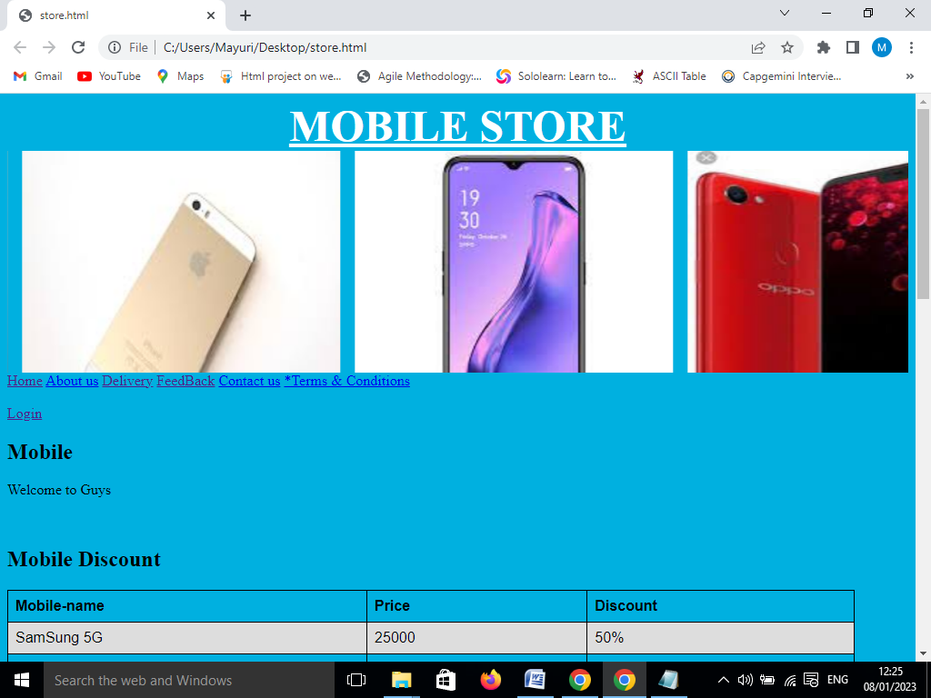

## Module-2 Table form-

To write a table of contents, you first write the title or chapter names of your research paper in chronological order. Secondly, you write the subheadings or subtitles, if you have them in your paper. After that, you write the page numbers for the corresponding headings and subheadings.

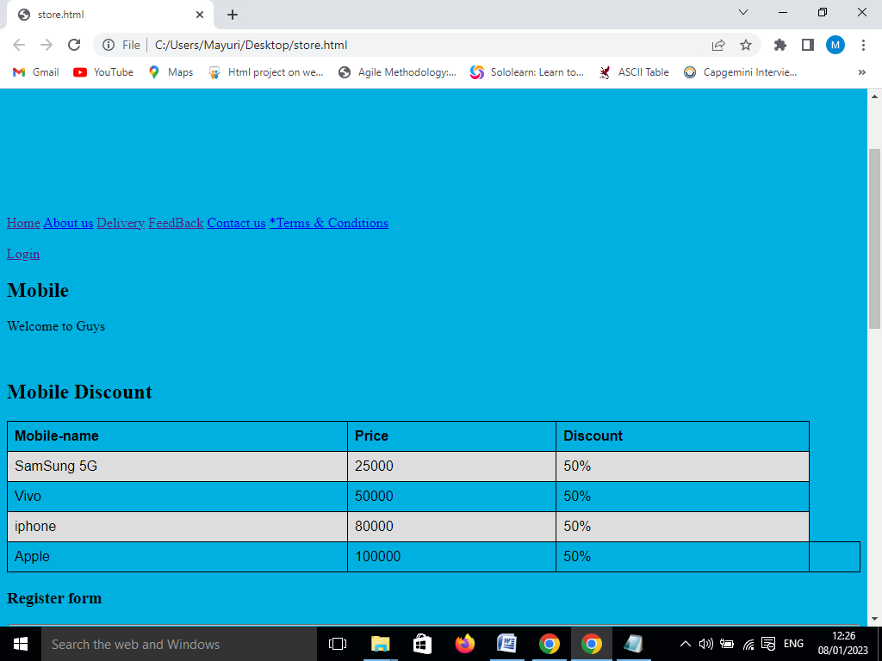

## Module-3 Registration Form

HTML Registration Form. Following are some different types of Forms: Code 1: The following code describes how to create a simple registration Page.

## 

## Module 4-FeedBack Form-

## 

## Module 5- Reference Link

HTML Links - The most important attribute of the <a> element is the href attribute, which indicates the link's destination. The link text is the part ...

This HTML reference describes all elements and attributes of HTML, including global attributes that apply to all elements. This page lists all the HTML elements, which are created using tags.

## Module 6-Terms and condition

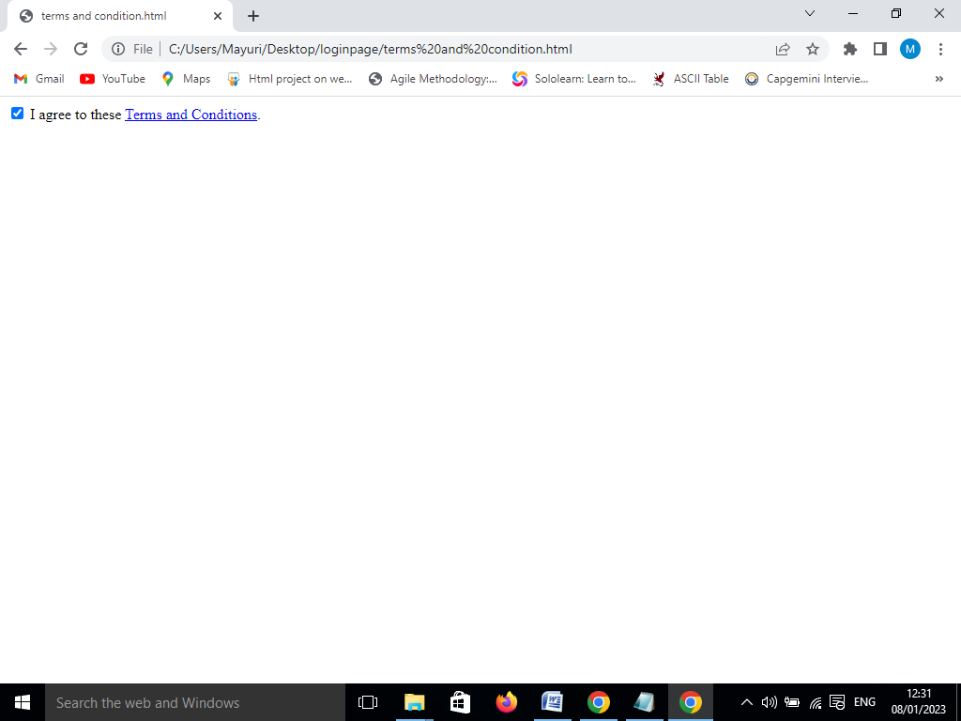

## Module 7-About us-

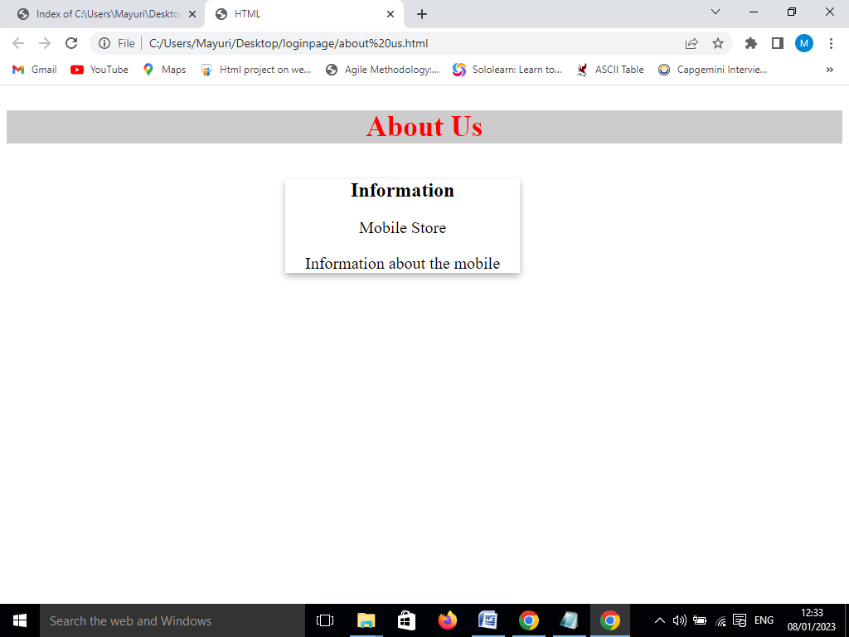

**Module 8-Login page**

